Title: Eu double dip
Subject: EEP 16

1. The sovereign debt crisis  A. Assessment  B. High public debt  C. Shift in Market expectations  D. Mechanism: doom loop!  2. Crisis Management  A. The early Crisis Management  a. Fiscal tool  b. Monetary Tool  B. The Crisis Management in 2011  a. Monetary Tool  C. Crisis gets worse in 2012  a. Fiscal Tools: ESM  I. What is it  II. Capital contributios  III. Decision making process  IV. Conditionalities  b. Monetary tools  c. Enhancing fiscal discipline  4. After the Crisis: the four arrow Strategy | 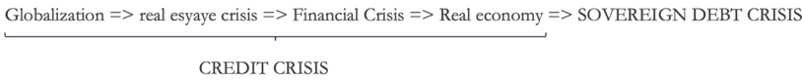  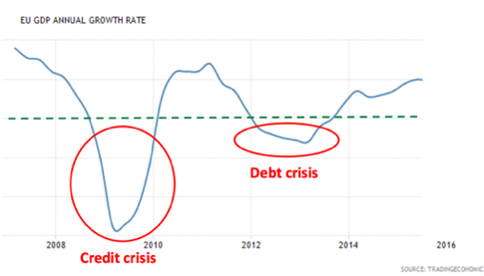  The crisis for Eu did not end in 2009.  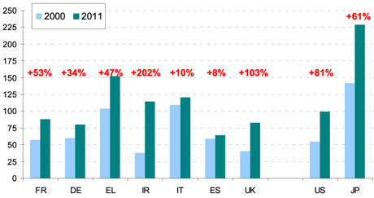  Due to the combined effects of fiscal stimulus and the cost of rescuing banks, together with the fall in GDP, public debt/GDP ratios increased across countries.  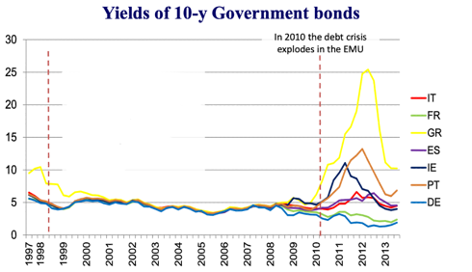  Mkts started to have doubts on debt sustainability in some euro area economies, with negative implications for growth  For many yrs we borrowed at the same yr, now huge spreads started to emerge  Negative feedback loop  0. Fiscal stimulus increased debt.  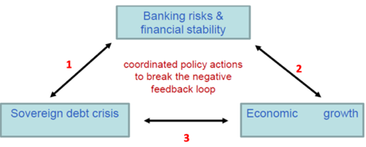  2. As debt increases Gov is perceieved as risky => higehr rates (higher debt/gdp), lower value of previously emitted bonds  2. Since banks already have sovereign bonds in their pf, increasing sovereign risk implies increasing banking risk (Assets going down, risk assets < liability), risk of baking default up, more difficulties in bank financing (overnight rates in trouble), leading to less credit to the economy (other banks will not lend) and lower growth.  3. Lower growth in turn worsens the sustainability of debt: low growth, more bail-outs  Initial problems:  i. At the beginning it was not even obvious that the EU had to intervene! It’s Greece problem, they have to get loan from IMF as everyione in the world. But, isn’t an Eu problem? Yes actually, the bank-sovereign negative feedback loop, if not stopped, endangers the entire monetary union.  ii. Ok what to do? There was Maastricht etc but the system was unfinished, there were no institutions/ specific procedures for managing such a crisis. Need to engineer the solutions starting from the existing juridical base (no bail out clause / ECB independence / decentralized fiscal policy).  Two general kinds of responses (applied in different ways at different points in time):  - Fiscal tools: allow countries to provide mutual financial guarantees (art. 125) to support sustainability of public debt  - Monetary tools via ECB: allow the cb to buy from the mkt sovereign debt bonds (obv indirectly), reducing borrowing costs of MS and improving banks' b/s  All of this this not happen in one day. Step by step:  EARLY CRISIS MANAGEMENT: EFSF and SMP  a. EFSF: an investment fund based in Luxemburg that issue AAA bonds on the mkt, guaranteed by one Eu country. The money so collected is used to finance a country in difficulty (e.g. Greece) at privileged rates (x% + operating costs). Loans are disbursed in tranches: one tranche in exchange one reform to restructure debt.  These were not Euro bonds: no joint guarantee. This is ocncistent with Maastricht: no bailout clause allowed for mutual financial guarantee.  Question: how can ita backed and German backed bonds be both AAA? wrt bonds backed by Italy, out of 100€ borrowed 90 went to Greece, 10 inevsted in AAA assets.  b. Securities Market Program (SMP); authorizes ECB to buy on the secondary market a sovereign bond with newly printed money. The  operation is sterilzed (that’s difference from QE). This was done to foster the proper working of the transition mechanism, not to expand Mp. No conditionality but letter by draghi, in which he said gov should consider fiscal reforms. But Berlusconi: there is no crisis in italy.  THE CRISIS MANAGEMENT IN 2011: LTRO  The Long Term Refinancing Operation: allow banks to borrow from cb at longer maturity (from 1 wk to 3 yrs) at 1%. No restrictions on how to invest.  CRISIS GETS WORSE IN 2012: ESM, OMT  As a response, two main crisis management tools (permanent!). Key difference = structurally formalized:  The European Stability Mechanism (ESM), a new EU Institution born with a traty signed in 2012. Next level of EFSF, that stops existing.  The ESM is a Luxembourg-based international financial institution. The ESM can do many things (500 bn lending capacity): grant loans to countries purchasing bonds of beneficiary MS on primary (!!!! Fiscal policy, ECB cannot) and secondary mkt and provide loans for recapitalisation of financial inst… But key difference is that bonds are backed by whole eu (joint guarantee), not country by country. Each country pays a proportional % of capital in the ESM. De Facto when it backs bonds these are Euro Bonds as for next generation Eu.  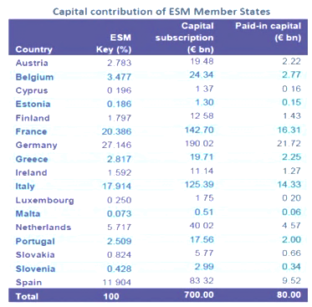  The 500 bn lending capacity is backed by capital contributions:  - Capital subscription (700 bn): This is a commitment made by member states to provide additional funds if needed.  - Paid-In capital (80 bn): This is the actual cash that member states have already contributed directly to the European Stability Mechanism (ESM).  The capital contributions depend on the key%, determined though population and size of econ.  Decisions to grant stability support are taken by mutual agreement (unanimity with possibility of abstention). However, in crisis situations in which the economic or financial sustainability of the eurozone is at risk, decisions may be taken by a qualified majority (85% of votes, assigned by keys: Ita, Fra and Ger can veto).  Financial assistance is linked to appropriate conditionality (the troika) specified in an agreement concluded by European Commission, ECB, IMF (= lose part of sovreignity) and beneficiary Member State.  About Troika, note: during Covid, before next gen eu, ESM would have granted loans up to 2% of GDP at very low rate. Nobody activated. Trauma of Greek troika: Very humiliating for Greece (gdp -25%) + economically did not make many sense. Increasing infant mortality. Punitive: let’s avoid moral hazard + not clear what are the conditions attached to it.  Note: What happens if there is a default of Greece?  EFSF: pari passu treatment.. You as a creditor you have no specila status-  ESM: Preferred crditur staturs (only junior to IMF)  The Outright Monetary Transaction program (whatever it takes thing). Next level of SMP, that stops existing.  Through OMT, the ECB can purchase bonds on the secondary markets (as with the SMP) to safeguard an appropriate monetary policy transmission (Not a tool for expansionary MP). Contrary to the SMP, OMT program characteristics are well defined:  3. Creditor treatment: Ecb accepts the same (pari passu) treatment => no penalization of private investors (convicne the mkt to buy the bonds of this market, if they know you will not lose anything).  4. Sterilisation  5. Transparency  Aggregate OMT holdings will be published on a weekly basis.  1. Conditionality to ESM:  strict and effective conditionality is a necessary condision (not gonna buy junk bonds) in the form of a full macroeconomic adj program, provided that these programmes include the possibility of ESM primary mkt purchases of sovereign debt. The involvement of the IMF to country-specific conditionality and the monitoring  Key: Ecb is fully indep in choosing, in accordance with its mandate, if start and when, but ESM is a minimum criterium. They stop whenever they want / when objectives are achieved, for sure when confiyiond are not respected.  2. Coverage:  Sovereign bonds with t between 1 and 3. No ex ante quantitative size limits  The ESM treaty and OMT go in parallel with the new Treaty on Stability (TSCG), the so-called ‘fiscal compact’ (2022):  Introduce in nat constitutions:  - Govs budgets shall be balanced or in surplus.  - The annual structural deficit must not exceed 0.5 % of GDP.  - MS whose gov debt exceeds the 60% reference level shall reduce it at an avg rate of 5%/yr as a benchmark  Amendments to the EU Treaties/SGP aimed at strengthening rules on fiscal discipline and coordination (we ended up in this situation bc they did not respsect fiscal discipline):  National budget laws /reforms are drafted in April in each year under the guidance of the EU Commission, approved by the EU institutions in June, and only then implemented by Member States.  Wrt EC requetst on the activation of several excessive deficit procedures to the Council…now Approevd unless QMV 65%, before needed 65% to approve.  Spread BTP-BUND is Termometer of the crisis  After the whatever it takes the acute phase of the crisis is over. However in 2015 europe enters a stagnant business cycle with deflationary pressures => need to structurally revamp the EMU. Need a coherent solution (recall we already are at 0%).  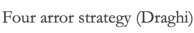  1. Monetary policy: QE.  - Unsterilized (expansonary) asset purchase programon the secondary mkt of gov bonds. To be carried until inflation goes back close to the 2% target.  - Purchases were allocated across countries according to ECB capital key; But can’t account for more than 25% of a single national issue, and for more than 33% of total issued debt.  - Ended 2018, but commitment to reinvestment policy (constant size of b/s).  - restarted after Sept 2019, and expanded over the Covid-19 pandemic (PEPP)  Note: FED had done it 7 yrs before, this is bc dual mandate allows it to intervene also to boost employment, while ECB could intervene only in case of price distrorstions = intervened when deflation occurred.  2. Financial policy:  LTRO expired in 2015 = now essentially there is a Mp restriction (banks have to pay back loans). We need:  - A banking union  - Credit easing: TLTRO, as LTRO but 4 yrs + targeted (lend to families and non financial firms, easying sov debt crisis no longer a prov).  4. Revamp productivity  Supply side reforms  3. Fiscal Policy:  High debt c had to follow strict fiscal rules (austerity) = contractionary fp, no borrowing  2 low debt c could have borrowed at low rates (ex. Ger), this would have created expansionary fp with positive spillovers but they did not want  c  Overall fp was contractionary. Solution?  - Draghi: less austerity for high debt (give more flexibility to spend in exchange of reforms) + rest has to spend.  - Junker plan: common Eu I plan take some money from the MFF and use it as a guarantee for loans from the European investment bank

